THE
EGYPTIAN
RHEUMATOLOGIST

The Egyptian Society For Joint Diseases & Arthritis.
Rheumatology & Rehabilitation Department,
Faculty of Medicine, Cairo University

MRI ASSESSMENT OF MILITARY RECRUITS WITH SUSPECTED
TIBIAL STRESS INJURIES
By
Faisal Omran, Al-Sayed El-Manzalawy, Noha Abd Elnassert, Hesham El-Shickh* & Sarhaf Kamara, FRCR*
From
Rheumatology Department, Faculty of Medicine, Al-Azhar & Benha Universities & Radiodiagnosis Department & Health Authority Hospitals, Abu Dhabi, UAE
ABSTRACT:
Objectives: This multicenter study was conducted to evaluate the diagnostic yield MRI and CT imaging and bone scintigraphy in patients with suspected tibial stress injury among military recruits.
Patients & Methods: Patients with unilateral lower leg discomfort lasting less than one-month, antalgic gait and/or decreased functional mobility and no history of trauma or indications of bone abnormalities on conventional radiography imaging of the lower leg were included in the research. MRI, CT, and bone scintigraphy were used to assess every patient.
Results: The patients had a mean (±SD) of 25±1.4 years and a mean pain duration of 18.9±6.9, range: 5-29 days. Mean pain score estimated at time of examination was 45.6±11.6, range: 25-70. MRI detected abnormalities in 40 patients, while CT examination and bone scintigraphy detected abnormalities in 21 and 28 patients, respectively with a significant increase of the frequency of detection of tibial abnormalities using MRI compared to CT and bone scintigraphy and a significant increase in favor of bone scintigraphy compared to CT. Marrow edema was detected in 23 patients using MRI and in 16 patients using bone scintigraphy but in only 2 patients using CT. On contrary, cortical abnormalities were detected in 15 patients using MRI and 12 patients using bone scintigraphy but were detected in 19 patients using CT. MRI detected cortical abnormalities with 79% sensitivity and 91% accuracy, while bone scintigraphy showed 63% and 84% respectively, versus CT that showed 100% sensitivity and accuracy for detecting cortical abnormalities. On the other hand, CT and scintigraphy showed a sensitivity of 9% and 70% and accuracy rate of 53% and 84%, respectively compared versus MRI that showed 100% sensitivity and accuracy for detection of marrow edema. MRI showed a significantly higher diagnostic yield in comparison to both other modalities with a significantly higher diagnostic yield of scintigraphy compared to CT.
Conclusion: Examining patients with suspected tibial stress should begin with MRI, however individuals with negative MRI results should have CT evaluation.
INTRODUCTION:

When the bone remodeling process fails to appropriately adapt to recurrent stress, tibial stress injuries result. Periostitis, medial tibial stress syndrome (MTSS), and tibial stress fracture are injuries caused by anterior or shin discomfort due from physical exercise. An estimated 10 to 20 percent of all injuries incurred by runners and 60 percent of all lower limb overuse disorders are attributed to shin discomfort. Athletes and military recruits are particularly vulnerable to suffering from shin discomfort ⁽¹⁾.
There are two hypotheses on the cause of anterior tibial discomfort. The most supported theory is the bone response theory. The MTSS lesion is caused by cortical bone hypermetabolism. Constant and increasing strain on porous bone encourages persistent skeletal remodeling. In response to changes in mechanical stress, it may be difficult for the bones of sportsmen to heal at an appropriate rate. In a perfect world, osteoblasts would fill the osteoclast-created tunnels. In pathological circumstances, however, the porous bone responds poorly to sustained loading, and microfissures or stress fractures may develop ⁽²⁾. It is known that bone remodeling occurs around five days after stimulation and that the bone is weakened throughout the first eight weeks of a workout plan ⁽³⁾.
Since the fascia of the soleus inserts on the posterior medial tibia or on the periosteum below the tibialis posterior, fascia of the soleus overuse syndrome is likely to be the source of anterior shin pain ⁽⁴⁾. This pain might be caused by periostitis or fasciitis. A small number of studies have shown no evidence of inflammation in patients with shin discomfort. This contributes to our knowledge of bone stress response. The notion of bone stress reaction is supported by the fact that 90% of all pain complaints start in parts of the tibia far distal to the proximal origins of the soleus, tibialis posterior, and flex- or digitorum longus muscles, according to previous research ⁽⁵⁾.
Although frequent, soreness in the lower legs caused by exercise is difficult to alleviate. According to Clanton and Solcher ⁽⁶⁾, a proper diagnosis necessitates a thorough examination, understanding of the many clinical manifestations, and the utilization of appropriate diagnostic tests. Due to the complexity of clinical and historical criteria, diagnosis frequently requires a high level of clinical suspicion ⁽⁷⁾. McCrory et al. ⁽⁸⁾ remarked, "Even for the most diligent physician, it may be difficult to distinguish between the several medical reasons due to the similarity of their presenting symptoms."
Numerous papers elaborate on the radiography, radioactive bone scanning, CT, and MR imaging features of tibial stress fractures ⁽⁹⁾. However, these trials usually included individuals whose symptoms persisted for weeks or months. However, early detection of tibial stress injuries may be critical for preventing stress fractures and associated consequences and encouraging early recovery ⁽¹⁰⁾.
The goal of this study was to evaluate the diagnostic yield of MRI, CT, and bone scintigraphy in military recruits with suspected tibial stress injury.
PATIENTS & METHODS:
This multicenter study was conducted at Afif General Hospital, Riyadh, KSA and Health Authority Hospitals, Abu Dhabi, UAE. After approval of the study protocol, patients with clinically suspected tibial stress injury were evaluated clinically and using conventional radiology.
All patients provided a complete history of the onset of pain (acute or gradual), location of pain (just in the leg vs. symptoms that may have proximal spine etiology), focal or diffuse (fracture vs. periositis / MTSS), activities that cause pain and when it occurs during the activity, and what activities cause pain and when it occurs during the activity (to rule out muscle-tendon pathology, or chronic exertional compartment syndrome). Factors such as a history of injury or inadequate recovery from a prior injury, low bone mineral density or poor nutrition/eating disorders, training methodologies, type and inclination of training surfaces, and type of footwear contributed to or aided the occurrence of strain. In addition, the kind and effectiveness of previous medications were evaluated.
In addition to examining the entire lower leg for abnormalities, edema, or redness, the footwear was also inspected for signs of wear. Posture was analyzed for anatomic traits that may contribute to tibial stress injury, including hindfoot varus and forefoot varus, both of which lead to excessive subtalar pronation, which increases the stress produced by the soleus and results in the tibia "bowing." Sharpey's fibers can carry increased stress from the soleus fascia's medial origin to the tibia, starting maladaptive remodeling ⁽⁵⁾.
Palpation of the tibia demonstrated substantial pain from the posterior medial tibia to the middle and distal thirds, which is diagnostic of MTSS ⁽¹¹⁾. If a stress fracture is suspected, one finger should be placed over the area of acute pain. The presence of pain at the anterior-lateral edge of the midshaft is symptomatic of an anterior cortical fracture. Stress fractures may be indicated by localized calluses, edema, or erythema. Additionally, pain caused by percussion or vibration may suggest a fracture ⁽⁴⁾. The discovery of gait analysis while running and walking was made. In addition, pain intensity was measured using a 100 mm visual analogue scale (VAS), with "O" representing no pain and "100" being the greatest agony ever experienced ⁽¹²⁾, To rule out alternative causes of leg discomfort in the lower extremities, a neurological examination was performed.
The experiment included patients with unilateral lower leg pain lasting less than one-month, antalgic gait and/or limited functional mobility, poor running, jumping, or training performance, and no history of trauma or evidence of bone abnormalities on conventional lower leg radiography.
All patients had MRI, CT, and bone scintigraphy examinations, respectively. With a 1.5-T system (Magnetom Vision; Siemens, Erlangen, Germany) with a phased-array coil, MR imaging exams were conducted. Transverse MR images were collected because they were simpler to compare with transverse CT scans, and the transverse plane has been shown to be optimal for detecting diffuse soreness stress injuries in the tibial shaft ⁽¹³⁾.
The MR imaging protocol along the posterior medial tibia to the middle and distal third, which is the hallmark of pulse sequences, comprised of the following: (a) a T1-weighted transverse MTSS ⁽¹⁾. Tibia was palpated for focal or lo- fast spin-echo sequence (repetition time msec/ echo time msec, 680/12; echo-train length, 3; section thickness, 3 mm; number of acquisitions, six; image matrix, 210 x 512; acquisition time, 4 minutes 49 seconds), (b) a transverse T2-weighted fast spin-echo sequence (5400/ 99; echo-train length, 11: section thickness, 3 mm; number of acquisitions, three; image matrix, 220 x 512; acquisition time, 5 minutes 29 seconds), and (c) a transverse fast short inversion time inversion-recovery (STIR) sequence (repetition time msec/echo time msec/ inversion time msec, 3600/60/150; echo-train length, 11; section thickness, 3 mm; number of acquisitions, four or six; image matrix, 242 x 256; acquisition time, 2 minutes 56 seconds or 4 minutes 24 seconds).
In order to pinpoint the lesion's craniocaudal extent, further coronal and/or sagittal MR images were taken based on the results of transverse MR imaging. CT was conducted with a Siemens Soma tom Sensation 16 scanner with the following scanning parameters: 2-mm collimation, 15-mm table increment, 120 kVp, and 120 mAs. All patients received radioactive bone imaging three to four hours after receiving an injection of 20 mCi (740 MBq) of technetium-99m methylene diphosphonate. The planar mode of a dual-head gamma camera was utilized for imaging.
Once pain-free ambulation is achieved, however, training can be resumed at a 50% intensity level. As long as the patient is free of symptoms, the dosage can be increased by 10% every week. Cross-training was established to enable sufficient time for recuperation after running and jumping sports. The anterior and posterior compartments were strengthened and stretched, and pelvic, hip, knee, and foot restrictions were evaluated and addressed accordingly. The implementation of running or leaping skill instruction programs.
RESULTS:
Only 45 patients fulfilled the criteria for inclusion in the study. Patients enrolled in the study had mean age of 25±1.4; range: 23-28 years. Mean duration of pain was 18.916.9; range: 5- 29 days. Mean pain VAS score estimated at time of examination was 45.6±11.6; range: 25- 70.
MRI detected abnormalities in 40 patients, while CT examination and bone scintigraphy detected abnormalities in 21 and 28 patients, respectively. There was a significant increase of the frequency of detection of tibial abnormalities using MRI compared both to CT (X2-17.26, p<0.001) and to bone scintigraphy (X2-8.379, p<0.01) with a significant increase of the frequency of detection of tibial abnormalities using bone scintigraphy compared to CT (X2-3.134, p<0.05), (Fig. 1).
Marrow edema was detected in 23 patients using MRI and in 16 patients using bone scintigraphy but was detected in only 2 patients using CT. There was a significant increase of the frequency of detection of tibial marrow edema using MRI compared both to CT (X2=113.16, p<0.001) and to bone scintigraphy (X2=3.116, p<0.05) with a significant increase of the frequency of detection of tibial marrow edema using bone scintigraphy compared to CT (X2=11.81, p<0.01), (Fig. 2). Periosteal edema was detected in 2 cases using MRI but could not be detected by either CT or scintigraphy.
On contrary, cortical abnormalities were detected in 15 patients using MRI and in 12 patients using bone scintigraphy but was detect-ed in 19 patients using CT examination which showed increased frequency of detection of cortical abnormalities that was significant versus bone scintigraphy (X2-4.435, p<0.01) but was non-significant versus MRI (X2-1.719, p>0.05), (Fig. 3).

MRI could detect cortical abnormalities with 79% sensitivity and 91% accuracy, while bone scintigraphy showed 63% and 84% respectively, versus CT that showed 100% sensitivity and accuracy of detection of cortical abnormalities with a non-significant difference of diagnostic validity tests between MRI and both CT and scintigraphy, (X2-0.261 & 0.136, p>0.05, respectively), but with a significantly decreased validity characters of scintigraphy compared to CT, (X2-6.474, p<0.01). On the other hand, CT showed a sensitivity of 9% and accuracy rate of 53% for detection of marrow edema and scintigraphy showed a sensitivity rate of 70% and accuracy rate of 84% com- pared versus MRI that showed 100% sensitivity and accuracy of detection of tibial marrow edema. MRI showed a significantly higher di- agnostic yield in comparison to both other modalities, (X2-225.36 & 15.592, p<0.001 & <0.01, respectively) with a significantly higher diagnostic yield of scintigraphy (X2-5.852, p<0.01) compared to CT. (Table 1).

Table (1): Test validity character of studied diagnostic modalities for detection of tibial cortical abnormalities and marrow edema
Sign |  | Sensitivity | Accuracy | Statistical Analysis
 |  |  |  | X2 | p
Cortical  abnormalities | MRI | 79% | 91% | 0.261 | >0.05
 | SC | 63% | 84% | 6.474 | <0.01
 | CT | 100% | 100% | 0.136 | >0.05
Marrow edema | MRI | 100% | 100% | 5.852 | <0.01
 | SC | 70% | 84% | 15.592 | <0.01
 | CT | 9% | 53% | 225.36 | <0.001

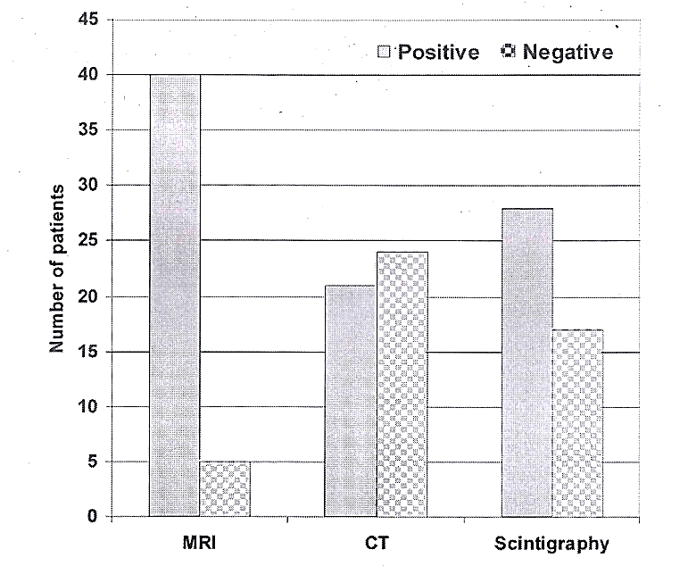
Fig. (1): Frequency of tibial abnormalities as detected by studied diagnostic
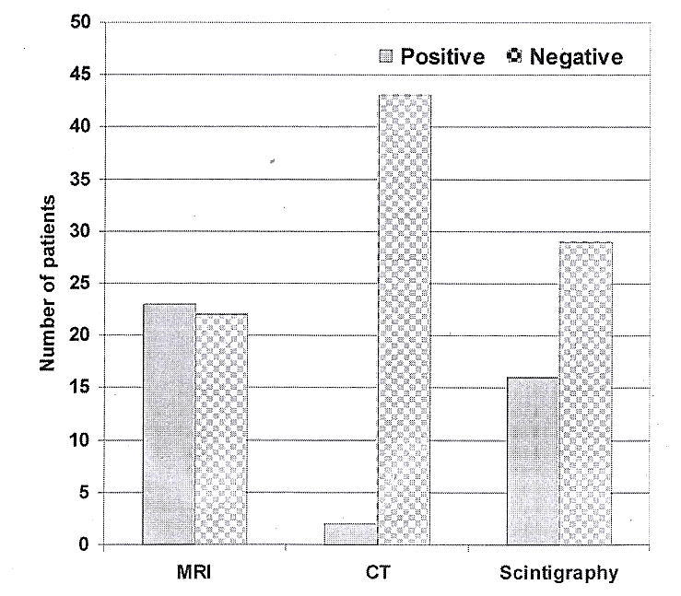
Fig. (2): Frequency of tibial marrow edema as detected by studied diagnostic modalities
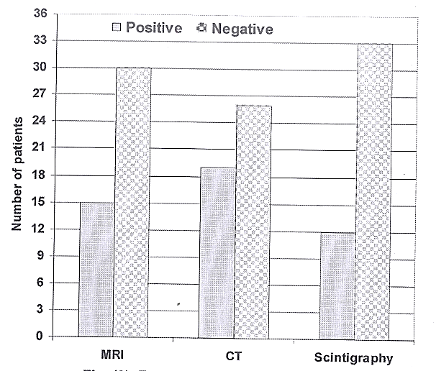
Fig. (3): Frequency of tibial abnormalities as detected by studied diagnostic modalities

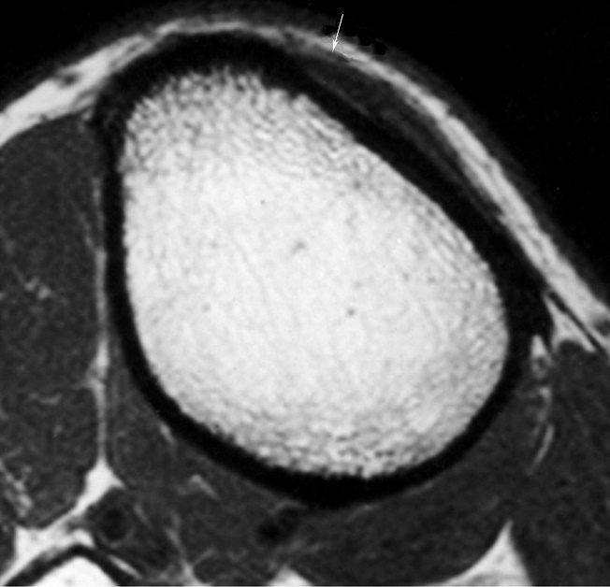
Case Presentation
Case (1): MR pictures of tibial periosteal edema collected from a 28-year-old patient with two weeks of left tibial discomfort:
- Transverse 3-mm-thick T1-weighted rapid spin-echo MRI (680/12) enabled visualization of non-specific soft-tissue enlargement (arrow) along the anterior-medial surface of the upper diaphysis. The cortical bone seemed healthy.
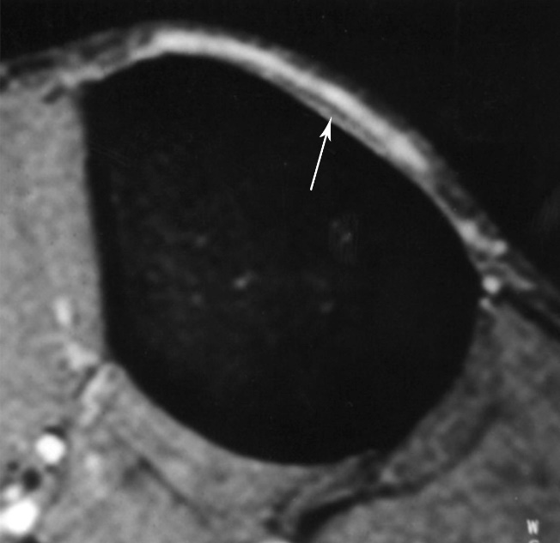
- Transverse rapid STIR MR images (3600/60/150) with a thickness of 3 mm revealed periosteal edema. As a signal void line, detached and thickened periosteum (arrow) could be observed. There was no cortical abnormalities evident.

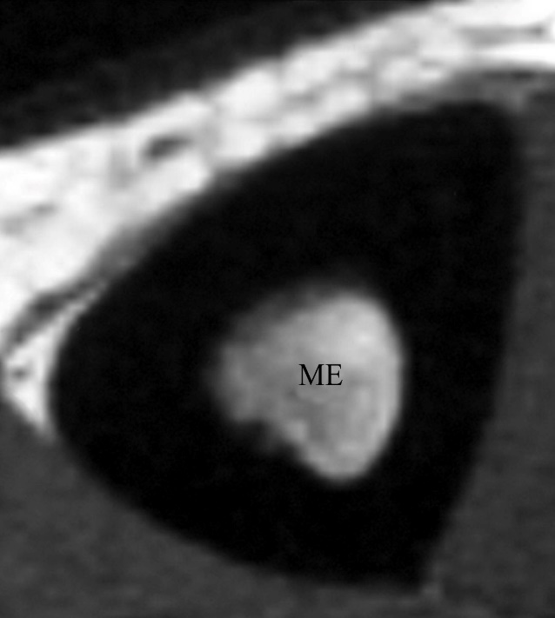
Case (2): MR imaging showing tibial bone marrow edema in an 18-year-old patient with three weeks of left tibial pain:
- Transverse 3-mm-thick T1-weighted fast spin-echo MR image (680/12) obtained at the level of the left midtibia shows hypointense bone marrow edema (BME).
- Along the anterior and medial cortex, a transverse 3-mm-thick rapid STIR MR picture (3600/60/150) acquired at the same level reveals BME and periosteal edema (PE).

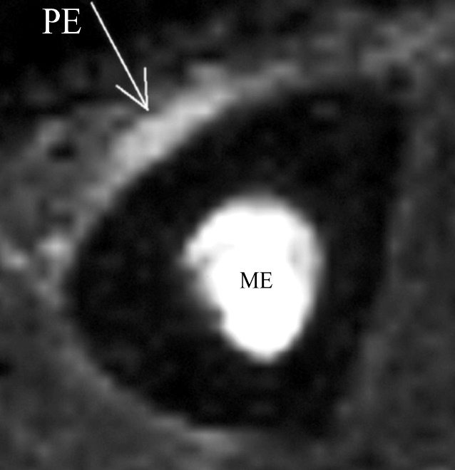
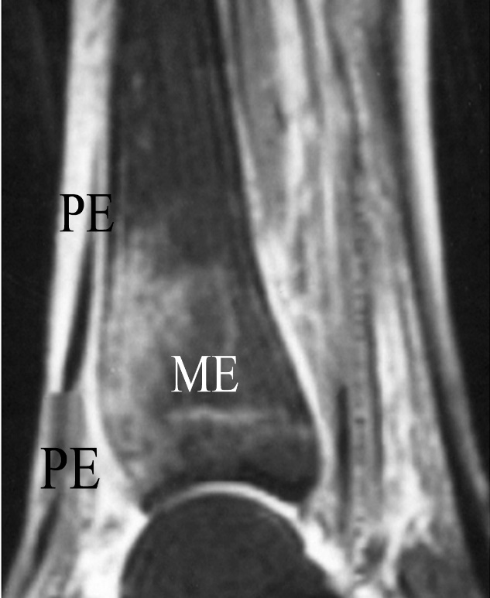
Case (3): MR imaging for a case of progressive tibial bone marrow and periosteal edema collected from a 19-year-old patient with 9 days of left tibial discomfort:
- Due to a stress lesion, the quick STIR sagittal MR scan (3600/60/150) indicated the presence of BME in the distal diaphysis. In addition, periosteal edema (PE) was seen.
- One week later, as a result of more training, MR imaging indicated a larger distribution of bone marrow eosinophilia and an increase in periosteal edema (PE).

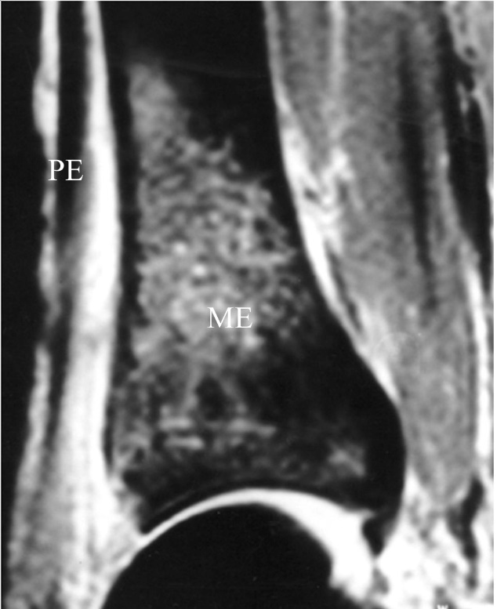
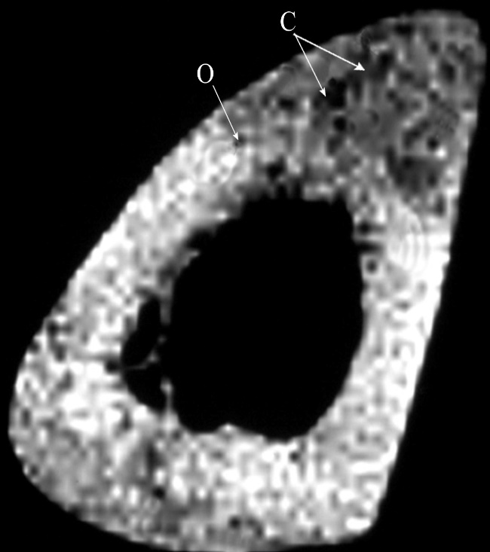
Case (4): CT and MR pictures show tibial cortical osteopenia and resorption cavities taken from a 22-year-old patient with 20 days of left tibial discomfort:
- A transverse CT scan with a thickness of 2 mm revealed evident osteopenia (O) of the anterior tibial cortex. In the anterior and posterior cortices, there were a few minute resorption cavities (C).
- The T2-weighted rapid spin-echo MR image (5400/99) reveals osteopenia (O) in addition to resorption cavities (C).

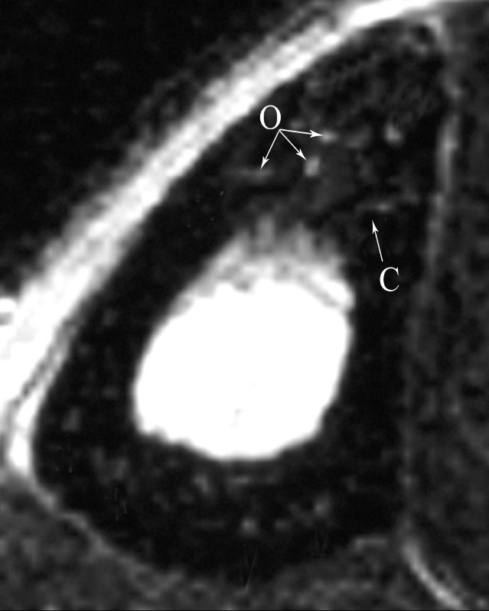
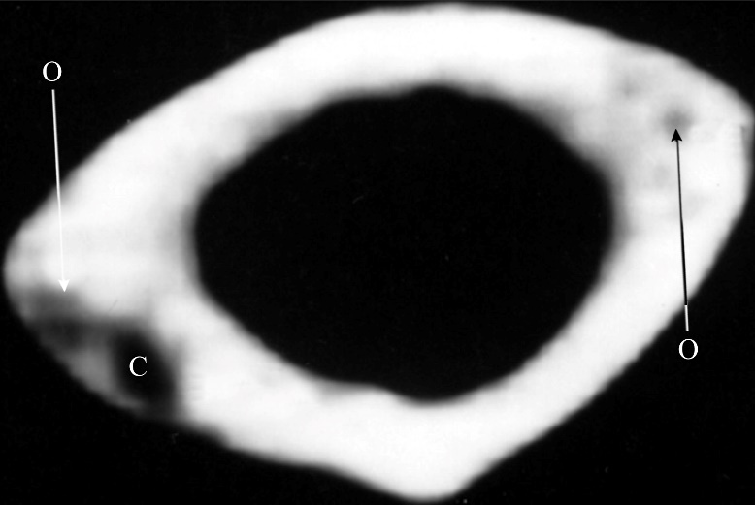
Case (5): Images depict tibial cortical osteopenia and resorption cavities obtained from a 23-year-old patient with left tibial pain for 18 days:
- A 2-mm-thick, high-resolution CT scan of the left midtibia revealed a 3-mm resorption chamber (C) in the posterior diaphyseal cortex. Both the anterior and posterior cortices exhibited osteopenia (zero).
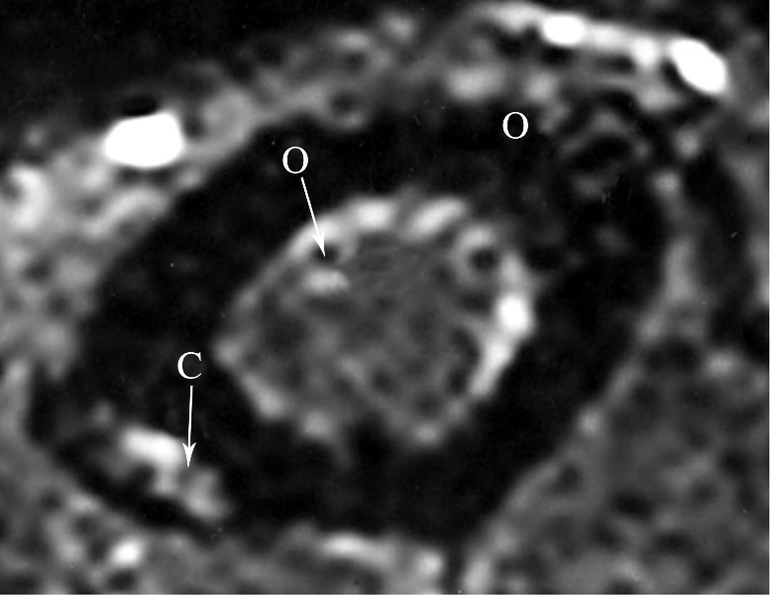
- A 3-mm-thick transverse fast STIR MR image (3600/60/150) revealed the presence of a resorption cavity containing tissue with a high signal intensity (C). Osteopenia was visible as circular and linear patches of intermediate signal intensity in the anterior brain (O). There was subperiosteal bone abnormality in the anterior cortex and endosteal edema (E).
- The posterior 99mTc methylene di-phosphonate scintigram indicated a moderate uptake in the posterior cortex of the left tibial diaphysis.

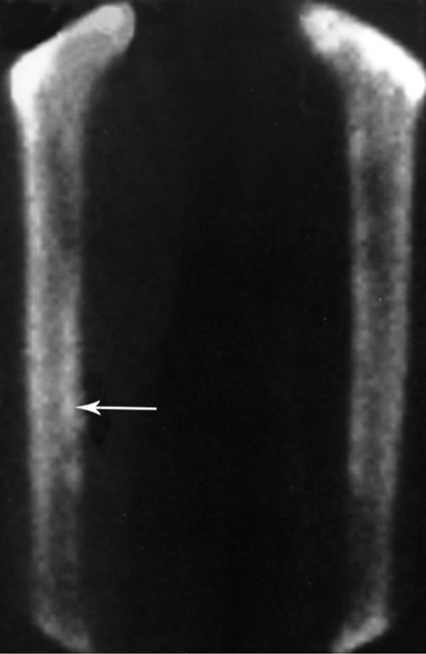
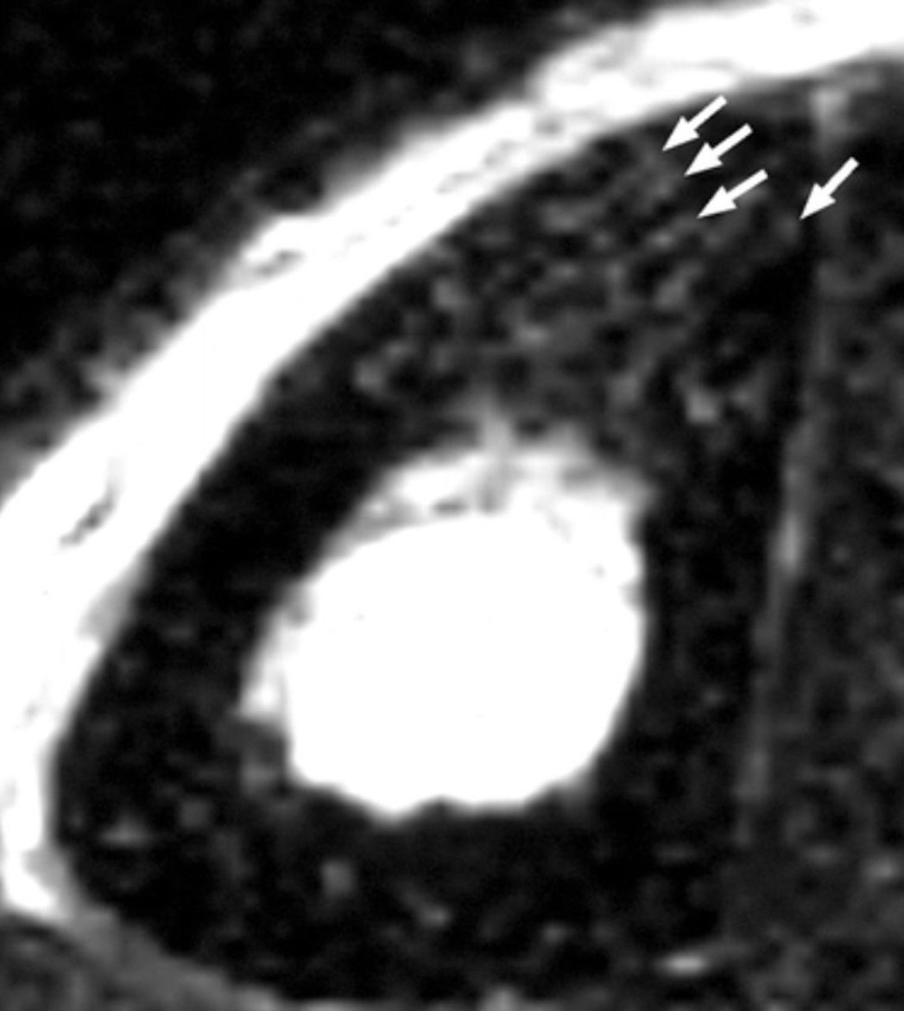
Case (6): Multiple parallel striations (arrows) were observed in the anterior tibial cortex on a transverse T2-weighted rapid spin-echo MR image (5400/99) taken from a 26-year-old patient with left tibial discomfort of three weeks' duration. There were obvious resorption cavities in the posterior cortex.

DISCUSSION:
One of the complications of stress injuries or one of these injuries is the stress fracture that is likely to be underreported, ⁽¹⁴⁾. The precise etiology of stress fractures is not well understood. Daily stressors accelerate the process of remodeling, and the initial response to abnormal stresses is an increase in osteoclastic resorption. If high levels of stress persist, an imbalance between bone resorption and bone repositioning will lead to bone degeneration. Muscle fatigue, muscle contractions, and weight-bearing can all increase bone stress ⁽¹⁵⁾. Along the anterior convex border of the tibia, tensile forces are generated, whereas compressive forces are generated along the posterior concave border. Microscopic fissures, osteopenia, and resorption voids may coalesce to generate larger lesions as a result of rapid intracortical remodeling. Stresses in cancellous bone may create microfractures in the beginning. The accumulation of micro damages may result in stress fractures of the cortical or trabecular bone if the triggering activity is not decreased ⁽¹⁶⁾.
Consequently, the imaging evidence of early stress lesions is a convincing rationale for averting the onset of a stress fracture and recommending the recruit to stop training. Her- ring et al. ⁽¹⁷⁾ discovered a statistically significant difference in the return time to training between younger than 20-year-old patients diagnosed with a stress lesion within 3 weeks of symptom start and those diagnosed with a stress lesion more than 3 weeks after symptom onset.
Through the present study, MRI could detect abnormalities in 40 patients, while CT ex- amination and bone scintigraphy detected abnormalities in 21 and 28 patients, respectively with a significant increase of the frequency of detection of tibial abnormalities using MRI compared both to CT and to bone scintigraphy and a significant increase in favor of bone scintigraphy compared to CT. The obtained data point to the superior diagnostic yield of MRI in comparison to other diagnostic modalities, taking into consideration that patients selected had negative conventional radiological examination.
These findings go in hand with the previously reported in literature; Savka & Shumeiko, ⁽¹⁸⁾ performed a comparative evaluation of quality of roentgenological and MRI data for the early diagnosis of overload injuries of bones and reported that MRI permits detecting changes in stress-induced injuries of bones 2-3 weeks earlier than X-ray does and concluded that MRI is an alternative in early diagnosis of stress-related injuries.
Bergman et al. ⁽¹⁹⁾ intended to determine if asymptomatic elite distance runners exhibit stress responses of the tibia on MR imaging and whether the presence of bone stress lesions predicts the future development of symptomatic tibial stress injuries. In 43% of asymptomatic distance runners examined, the presence of these changes was found to be a predictor of future tibial stress reactions or stress fractures. Also, Niemeyer et al. ⁽²⁰⁾ supported a full and early diagnostic examination (including MRI) and consistent therapy if the medical history and clinical presentation of a patient reveal the presence of a stress injury. Hamdi et al. ⁽¹⁶⁾ investigated the diagnostic effectiveness of radiology and MRI in assessing persons with stress injury in the military and concluded that radiography was useless; MRI was the preferred investigation.
Marrow edema was detected in 23 patients using MRI and in 16 patients using bone scintigraphy but was detected in only 2 patients us- ing CT with a significant increase of the frequency of detection of tibial marrow edema using MRI compared both to CT and bone scintigraphy. These findings agreed with Savka & Shumeiko, ⁽¹⁸⁾ who reported that MRI has been shown to allow a higher significance judgment about changes taking place in soft and paraossal tissues of the extremity in stress- induced fractures.
On contrary, cortical abnormalities were detected in 15 patients using MRI and in 12 patients using bone scintigraphy but were detected in 19 patients using CT examination which showed increased frequency of detection of cortical abnormalities that was significant versus bone scintigraphy but was non-significant versus MRI. These data coincided with that re- ported by Gaeta et al., ⁽²¹⁾ who high-resolution CT has high diagnostic accuracy in depicting cortical abnormalities in patients with medial tibial stress syndrome and cortical abnormalities can also be seen in some asymptomatic distance runners.
MRI could detect cortical abnormalities with 79% sensitivity and 91% accuracy, while bone scintigraphy showed 63% and 84% respectively, versus CT that showed 100% sensitivity and accuracy of diagnosis of cortical abnormalities a finding that agreed with Gaeta et al., ⁽²¹⁾ who reported a sensitivity rate of 100% for high-resolution CT in diagnosis of tibial cortical abnormalities.
Based on the superiority of MR imaging for detection of marrow and periosteal edema and the non-significantly decreased sensitivity and accuracy of diagnosis of cortical abnormalities when compared to CT, MR imaging could be considered the first-line diagnostic modality for examination of patients with suspected tibial stress; however, patients with negative MRI findings should undergo CT examination.
REFERENCES:
- Ruohola JP, Kiuru MJ and Pihlajamaki HK (2006): Fatigue bone injuries causing anterior lower leg pain. Clin Orthop Relat Res.; 444: 216-23.
- An MY, Ma AJ, Li YH and Wan YM (2005): Simula- tion of the rat tibial bone density changes with the finite element method. Space Med Med Eng (Beij- ing); 18(1):55-7.
- Sofka CM (2006): Imaging of stress fractures. Clin Sports Med. 25(1):53-62
- Beck BR (1998): Tibial stress injuries. An etiological review for the purposes of guiding management. Sports medicine; 26(4) 265-79.
- Yates B and White S (2004): The incidence and risk factors in the development of medial tibial stress syndrome among naval recruits. Am J Sports Med; 32(3) 772-80.
- Clanton TO and Solcher BW (1994): Chronic leg pain in the athlete. Clin Sports Med; 13: 743-59.
- Maitra RS and Johnson DL (1997): Stress fractures: clinical history and physical examination. Clin Sports Med; 16:259-74,
- McCrory P. Bell S and Bradshaw C (2002): Nerve en- trapments of the lower leg, ankle and foot in sport. Sports Med.; 32: 371-91.
- Spitz DJ and Newberg AH (2002): Imaging of stress fractures in the athlete. Radiol Clin North Am..40:313-31
- Ohta-Fukushima M, Mutoh Y. Takasugi S, Iwata H and Ishii S (2002): Characteristics of stress fractures in young athletes under 20 years. J. Sports Med Phys Fitness; 42:198-206
- Hutchchinson, Mark R. MD, Cahoon SM and Atkins TM (1998): Chronic Leg Pain: Putting the Diagnos- tic Pieces Together. The Physician and Sports medicine: Vol 26(No 27).
- Scott J and Huskisson EC (1976): Graphic representation of pain. Pain: 2: 175-84.
- Ahovuo JA, Kiuru MJ, Kinnunen JJ, Haapamaki V and Pihlajamaki HK (2002): MR imaging of fatigue stress injuries to bones: intra- and interobserver agreement. Magn Reson Imaging: 20:401-6.
- Milner CE, Ferber R, Pollard CD, Hamill J and Da- vis IS (2006): Biomechanical factors associated with tibial stress fracture in female runners. Med Sci Sports Exerc.;38(2):323-8.
- Drabicki RR, Greer WJ and DeMeo PJ (2006): Stress fractures around the knee. Clin Sports Med.; 25(1):105-15
- Hamdi M. Zrig M, Bellesoued A, Khezami M, Ben Chaabane T, Khechelfi S, Nouisri L and Khalil A (2007): Stress fracture locations in military personnel. Tunis Med.:85(2):137-42.

- Herring KM (2006): A plyometric training model used to augment rehabilitation from tibial fasciitis. Curr Sports Med Rep.; 5(3):147-54.
- Savka IS and Shume ko NF (2003): Magnetic- resonance imaging in the diagnosis of overload inju ries of bones. Lik Sprava.: (5-6):64-7.
- Bergman AG, Fredericson M, Ho C and Matheson GO (2004): Asymptomatic tibial stress reactions: MRI detection and clinical follow-up in distance runners. Kathmandu Univ Med J (KUMJ), 2(4):315- 23.
- Niemeyer P, Weinberg A, Schmitt H. Kreuz PC, Ewerbeck V and Kasten P (2006): Stress fractures in adolescent competitive athletes with open physis. Knee Surg Sports Traumatol Arthrose.; 14(8):771-7:
- Gaeta M, Minutoli F. Vinci S. Salamone 1, D'Andrea L, Bitto L, Magaudda L. and Blandino A (2006): High-resolution CT grading of tibial stress reactions in distance runners. AJR Am J Roentgenol.; 187 (3):789-93.

